PHASE 1: UNDERSTANDING ADAPTIVE SOFTWARE DEVELOPMENT
Study ASD Characteristics
- Students study the following key ASD characteristics:
  - Mission-focused development
  - Component-based development
  - Time-boxed iterations
  - Risk-driven and change-tolerant planning
  - Continuous learning

- Student Task:
  - Write one short explanation for each characteristic
    - Mission-focused development: Focus on overall project goal instead of fixed requirements.
    - Component-based development: Build the system using separate modules that can be changed easily.
    - Time-boxed iterations: Work is done in fixed short cycles with small deliverables.
    - Risk-driven & change-tolerant planning: Plans are flexible and address risks early, allowing changes.
    - Continuous learning: Teams improve through feedback and lessons from each cycle.

  - Identify why traditional planning fails in uncertain environments
    - Traditional planning assumes stable requirements and fixed plans. In uncertain environments, requirements change often, so rigid plans become outdated, causing delays and rework.

Understand the SCL Cycle
- Understand the three phases:
  - Speculate → What do we believe will work?
  - Collaborate → How do stakeholders and teams work together?
  - Learn → What did we learn and how do we adapt?

- Student Task:
  - Write one example for each phase from real-world software projects
    - Speculate (What do we believe will work?)
A food delivery startup plans to add a live order tracking feature because they believe customers want real-time updates to improve satisfaction.
    - Collaborate (How do stakeholders and teams work together?)
Developers, designers, delivery partners, and customers test the tracking feature together, share feedback, and suggest improvements before full release.
    - Learn (What did we learn and how do we adapt?)
After release, data shows users care more about delivery time accuracy than map tracking, so the team improves ETA prediction instead of adding more map features.

- Based on learning:
  - Modify backlog priorities
  - Add/remove user stories
  - Plan next iteration differently

Adaptation & Re-Speculation
- Expected Outcome:
  - Visible evidence of adaptive evolution.
    - Backlog Changes After Learning
      - Modified Priorities
        - Enroll in course – High
        - Drop course after enrollment – High
        - Browse courses – Medium
        - Modify course availability – Medium
    - User Stories Updated
      - Added: Drop course after enrollment (new student need)
      - Enrollment story updated to include seat release after drop
    - Next Iteration Plan
      - Focus on enrollment + drop workflow together
      - Validate seat updates and student notifications
      - Collect feedback on schedule flexibility

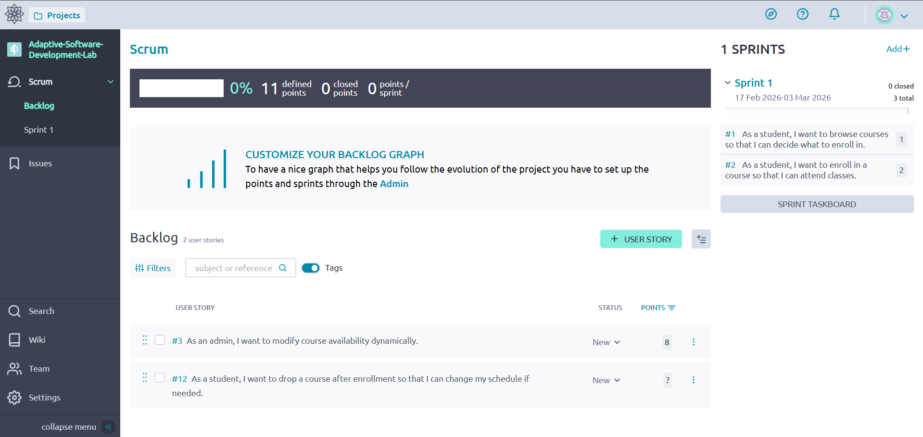
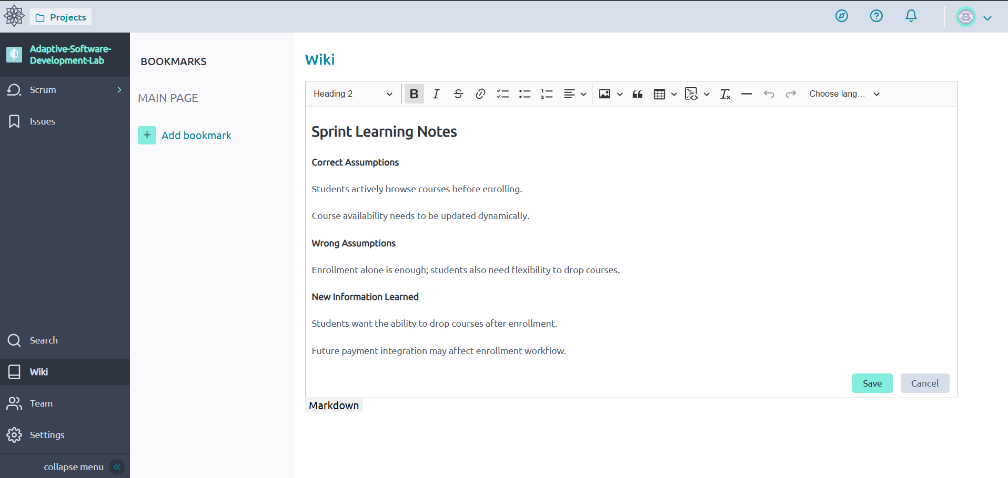

Reflection on ASD Project Implementation
Working on this project helped me understand how Adaptive Software Development differs from traditional planning. Instead of fixing requirements at the beginning, we started with assumptions and refined them through collaboration and feedback. During Sprint 1, stakeholder comments revealed new needs, such as allowing students to drop courses after enrollment. This showed how real projects evolve when users interact with the system.
The speculative backlog helped us prioritize features based on value rather than rigid plans. Team collaboration through task division, feedback discussions, and backlog updates demonstrated how shared decision-making improves software quality. Documenting learning in the wiki also made it clear that continuous reflection helps teams adapt quickly and avoid repeating mistakes.
Overall, this activity showed that ASD works well in uncertain environments because it supports flexibility, learning, and stakeholder involvement. I learned that successful software development is not just about coding features, but about responding to change, validating assumptions, and improving the system iteratively based on real feedback.

